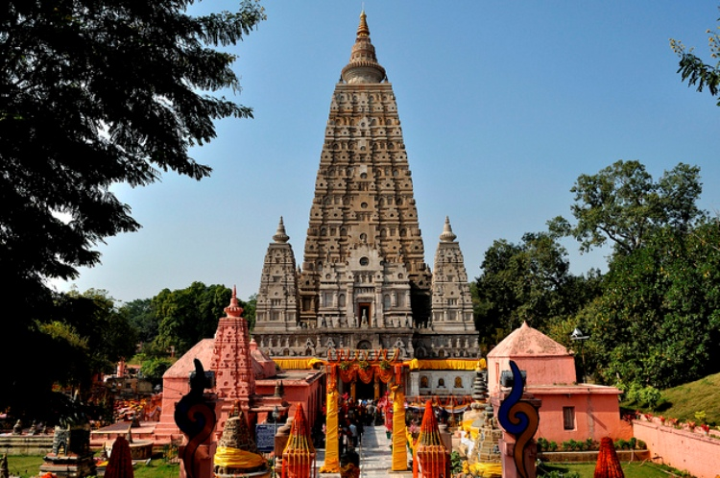

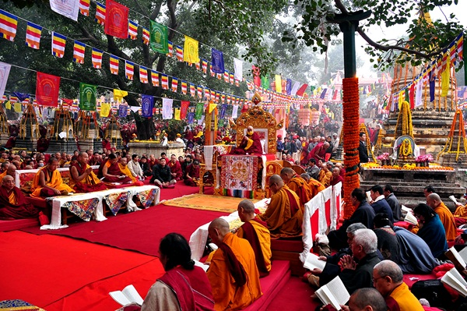

Kaalchakra 2016 Schedule
S.No. | TIME | PROGRAMME
1 | January 14, 2016 Thursday | Kalachakra Ritual Preparation
 | 10:00 hrs – 11:00 hrs | Prayers (3h00m)
 | 11:30hrs – 12:30 hrs | teaching for disciples (1 h00m)
 | 12:30 hrs – 14:00 hrs | Lunch
 | 12:30hrs – 14:00hrs | Prayers (1h30m)
2 | January 15, Friday | Kalachakra Ritual Preparation
 | 07:00 hrs – 11:30 hrs | Prayers (4h30m)
 | 11:30 hrs – 12:30 hrs | Lunch
 | 12:30 hrs – 14:00 hrs | Earth Ritual Dance (1h30m)
 | 14:00 hrs – 16:00 hrs | Prayers (2h00m)
3 | January 16, Saturday | Kalachakra Ritual Preparation
 | 07:00 hrs – 11:00 hrs | Prayers (4h00m)
 | 11:30 hrs – 12:30 hrs | Lunch
 | 12:30 hrs – 15:00 hrs | Prayers (2h30m)
4 | January 17, Sunday | Preliminary Teachings – Day 1
 | 09:00 hrs – 11:30 hrs | Teaching
 | 11:45 hrs – 13:00 hrs | Lunch
 | 13:00 hrs – 15:00 hrs | Prayers (2h00m)
5 | January 18, Monday | Preliminary Teaching – Day 2
 | 09:00 hrs – 11:30 hrs | Teaching
 | 11:45 hrs – 13:00 hrs | Lunch
 | 13:00 hrs – 15:00 hrs | Prayers (2h00m)
6 | January 19, Tuesday | Preliminary Teachings – Day 3
 | 09:00 hrs – 11:30 hrs | Teaching
 | 11:45 hrs – 13:00 hrs | Lunch
 | 13: 00 hrs – 15:00 hrs | Prayers (2h00m)
7 | January 20, Wednesday | Kalachakra Ritual and Offering Dance
 | 07:00 hrs – 11:30 hrs | Prayers (4h30m)
 | 11:30 hrs – 13: 00 hrs | Lunch
 | 13:00 hrs – 14:00 hrs | Ritual Offering Dance
 | 14:00 hrs – 15:00 hrs | Prayers (1h00m)
8 | January 21, Thursday | Students Preparation (Preliminary Initiation)
 | 07:00 hrs – 11:00 hrs | Self-Generation (4h00m)
 | 11:00 hrs – 12:00 hrs | Lunch
 | 12:00 hrs – 15:45 hrs | Preparation Initiation for students (3h45m)
9 | January 22, Friday | Kalachakra Initiation
 | 07:00 hrs – 11:30 hrs | Self-Generation Prayers (4h30m)
 | 11:30 hrs – 12:30 hrs | Lunch
 | 12:30 hrs – 16:00 hrs | Kalachakra Initiation (3h30m)
10 | January 23, Saturday | Kalachakra Initiation (15th day of 11th Tibetan Month)
 | 06:00 hrs – 11:00 hrs | Self-Generation Prayers (5h00m)
 | 11:00 hrs – 12:00 hrs | Lunch
 | 12:00 hrs – 16:00 hrs | Kalachakra Initiation (4h00m)
11 | January 24, Sunday | Kalachakra Initiation
 | 07:00 hrs – 11:30 hrs | Self-Generation Prayers (4h30m)
 | 11:30 hrs – 12:30 hrs | Lunch
 | 12:30 hrs 16:30 hrs | Kalachakra Initiation (4h00m)
12 | January 25, Monday | Long Life Empowerment for the Public and Long Life Ceremony for His Holiness the Dalai Lama
 | 07:30 hrs – 08:00 hrs | Self-Generation Prayers
 | 08:00 hrs – 11:30 hrs | Long Life Empowerment for the Public and Long Life Ceremony for His Holiness the Dalai Lama
 | 11:45 hrs – 13:00 hrs | Lunch

